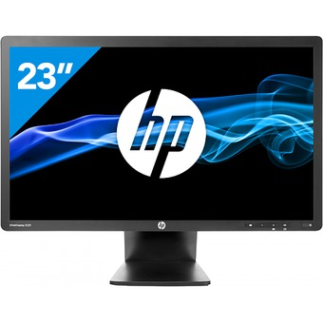

Monitor HP EliteDisplay E231 Monitor LED Gama Alta 23" , Full HD, DVI/VGA/display Port con USB . Giro 360 grados, Pivotable.

1 año de garantia

23" (58.4cm) FHD LED Monitor, DVI, VGA, USB & DisplayPort, 360deg Tilt & Swivel

Precio Original 289 €

HP PN: C9V75AA
EAN: 8871117745908
Packaging:
Individual Generic Brown Box
Includes: 1 x Power Cord (UK or EU), 1 x VGA Cable, 1 x DVI Cable
Price €95.00eur ea (Delivered EU)
Grade A Refurbished
Factory Recertified by A2C
Warranty: 1 Year RTB
For Full HP PDF Specification please see here

